Logarithm Equation with different bases

Trinh

For the logarithm equation in this Unit 4, I come up with three ways to solve the log equation with different bases. Any other ways you can think of?

Solve $\log_{2}\left(x\right)=\log_{3}\left(x+1\right);x>1$

**Change base #1**

With $\log_{2}\left(x\right)=\frac{log\left(x\right)}{\log{2}}$ and $\log_{3}\left(x\right)=\frac{log\left(x+1\right)}{\log{3}}$

We have $\frac{log\left(x\right)}{\log{2}}=\frac{log\left(x+1\right)}{\log{3}}$

Multiply by log(2) $log\left(x\right)=\frac{log⁡(2)∙log\left(x+1\right)}{log\left(3\right)}$

$log\left(x\right)-\frac{\log\left(2\right)∙log\left(x+1\right)}{log\left(3\right)}=0$

$\log\left(x\right)-{\log\left(x+1\right)}^{\frac{\log\left(2\right)}{\log\left(3\right)}}=0$

$log\left(\frac{x}{{(x+1)}^{\frac{\log\left(2\right)}{\log\left(3\right)}}}\right)=0$

Convert to exponent

$\frac{x}{{(x+1)}^{\frac{\log\left(2\right)}{\log\left(3\right)}}}={10}^{0}$

$x={\left(x+1\right)}^{\frac{log⁡(2)}{log⁡(3)}}$

Solve by graph 🡺 x = 2

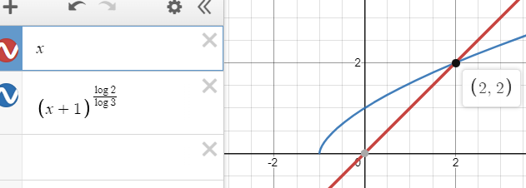

**Change base #2 $$\log_{2}\left(x\right)=\log_{3}(x+1);x>1$$**

With $\log_{3}\left(x+1\right)=\log_{3}\left(2\right)∙\log_{2}(x+1)$

We have $\log_{2}\left(x\right)=\log_{3}\left(2\right)∙\log_{2}(x+1)$

Or $\log_{2}\left(x\right)-\log_{3}\left(2\right)∙\log_{2}\left(x+1\right)=0$

$\log_{2}\left(x\right)-\log_{2}{\left(x+1\right)}^{\log_{3}(2)}=0$

$\log_{2}\left(\frac{x}{{\left(x+1\right)}^{\log_{3}(2)}}\right)=0$

Convert to exponent

$\frac{x}{{\left(x+1\right)}^{\log_{3}(2)}}=2^{0}$

$x={\left(x+1\right)}^{\log_{3}(2)}$

Solve by graph 🡺 x = 2

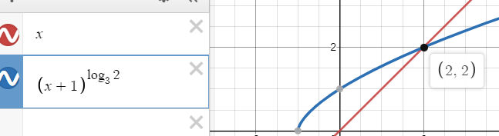

*This is actually the same concept with the previous one, but just more elegantly in writing out.*

**USub to exponent**

$$\log_{2}\left(x\right)=\log_{3}(x+1);x>1$$

Let ${t= log}_{2}\left(x\right)→ x=2^{t}$

We have ${t= log}_{3}\left(2^{t}+1\right)$

Convert to exponent

$3^{t}=2^{t}+1$

(Both are monotonic increasing function, they only intersect at one point)

Solve by graph t = 1

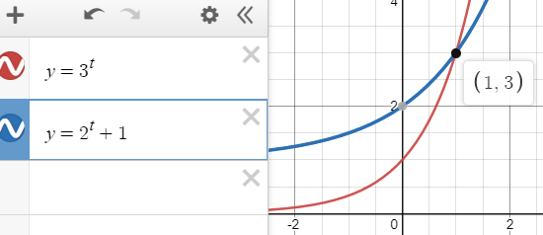

$$t= \log_{2}\left(x\right)=1→x=2^{1}=2$$

**Other method ?**

One more problem next

Solve $\log_{2}\left(x\right)+\log_{3}\left(x\right)=1;x>0$

**Change base**

$\log_{2}\left(x\right)+\log_{3}\left(2\right)∙\log_{2}\left(x\right)=1$

$\log_{2}\left(x\right)\left(1+\log_{3}\left(2\right)\right)=1$

$\log_{2}\left(x\right)=\frac{1}{1+\log_{3}\left(2\right)}$

$x=2^{\frac{1}{1+\log_{3}\left(2\right)}}≈$ 1.529

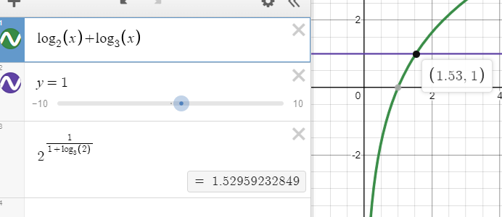

**USub to exponent**

$\log_{2}\left(x\right)+\log_{3}\left(x\right)=1;x>0$

Let ${t= log}_{2}\left(x\right)→ x=2^{t}$

We have ${t+ log}_{3}\left(2^{t}\right)=1$

$\log_{3}\left(2^{t}\right)=1-t$

$2^{t}=3^{1-t}=\frac{3^{1}}{3^{t}}$

$2^{t}∙3^{t}=6^{t}=3$

$t=\log_{6}3$

$x=2^{t}=2^{\log_{6}3}≈1.529$

